BAND CAMP
It’s almost that time of year again,
The Dunbar band camp will soon begin.
I’ll be putting in hundreds of hours,
The practice field my new home.
Sunscreen, water and the metronome.
While others are inside with the A/C crankin’,
I’ll be on the practice field bakin’,
So hot I feel like faintin’.
But I’ll march and I’ll play everyday,
Because that’s ‘the Dunbar way’.
We ALL make a difference out on the field,
Everyone playing, every spot filled.
At the end of it all, I’ll get to perform,
To show everyone what WE have done.
The pride and excitement that I will feel,
The roar of the crowd as we enter the field.
One day I’ll look back with fond memories
Of how this experience has shaped me
Dedication
Endurance
Leadership
Just to mention a few
It’s AMAZING what being in band can do!

YOU can help make a difference
All it takes is a few cents!
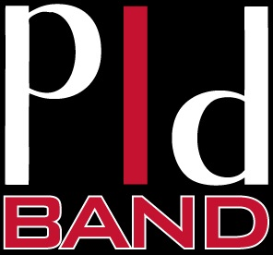
Name of student______________________________________
Will you sponsor me during band camp?
My Goal is $_____
You can make a flat donation or a pledge…
For example:
- .05 cents X 100 hours of camp = $5.00
- .10 cents X100 hours of camp = $10.00
- .25 cents X 100 hours of camp = $25.00
- $1.00 X 100 hours of camp = $100.00

All money is due at the end of camp on Friday 8/5/16. Please make checks payable to PLD Band.
Total collected
$_________
Name | Phone number | Donation/Pledge  $ amount | Collected y/n

